Bestxyz processor

User Manual

Edwards AFB, CIV USAF 412 RA (USA)

Written By: Hannselthill Camacho (Student Trainee)

TABLE OF CONTENTS

1. SETUP INFORMATION 1

1.1 Physical Equipment 1

1.2 Compatible Operating Systems 1

1.3 User Provided Information 1

1.4 Installation and Execution 1

2. INTRODUCTION 2

2.1 Functional Description 2

2.2 Getting Started 2

3. KNOWN BUGS 8

TABLE OF FIGURES

Figure 1: File selection entry fields 2

Figure 2: Opening the file browse dialog by clicking the highlighted button shown above 2

Figure 3: Selecting a Novatel data input file using the file browser 3

Figure 4: The selected input file path is shown 3

Figure 5: GPS Antenna Position text entry fields and file browser button 4

Figure 6: GUI ready to begin processing 4

Figure 7: GUI during processing 5

Figure 8: Post run GUI with Processing Information populated 6

Figure 9: Truncated image of the output data file after processing 6

Figure 10: Output Log file after processing 6

# SETUP INFORMATION

## 1.1 Physical Equipment

A modern computer or laptop capable of running windows 10 operating system is required to run the application.

## 1.2 Compatible Operating Systems

The application has been tested and created to work in a windows 10 environment. The application has not been tested in Linux, Mac, or earlier versions of windows OS.

## 1.3 User Provided Information

The user is expected to have a reference receiver dataset that follows the [OEM7 Commands and Logs Reference Manual](https://docs.novatel.com/oem7/Content/Home.htm) message specifications.

The user is expected to provide the Earth Centered Earth Fixed E, F, and G coordinates by either loading them from a valid file or manually inputting them into the provided text fields in the GUI.

## 1.4 Installation and Execution

Extract the “BestXYZ_Processor.zip” file into the desired directory. Run the “Project_1.exe” executable to start the application.

# INTRODUCTION

## 2.1 Functional Description

The BestXYZ Processor application is composed of a rich GUI interface made using QT Creator 4.12.4 Community open source edition. The application takes in a Novatel data file and three GPS antenna coordinates either through direct entry or loaded from a file. The application can parse Time, Range, and BestXYZ messages for relevant data used in calculating positional differences and a Root Sum Squared (RSS) of those differences. The collected and calculated data is written into an outputFile that is either specified by the user or generated by the application. A log is also created with metrics including but not limited to start time, end time, and number of records processed.

## 2.2 Getting Started

1. Run the “Project_1.exe” executable located in the directory of the unzipped “BestXYZ_Processor.zip”
2. Specify a Novatel data file in one of two ways.

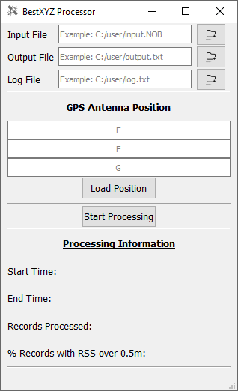

Figure : File selection entry fields

* 1. By directly entering the file path into the “Input File” text entry field.

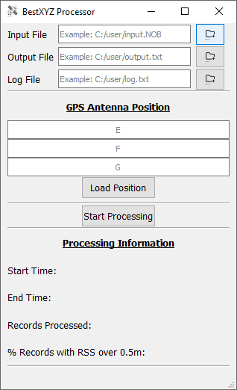

Figure : Opening the file browse dialog by clicking the highlighted button shown above

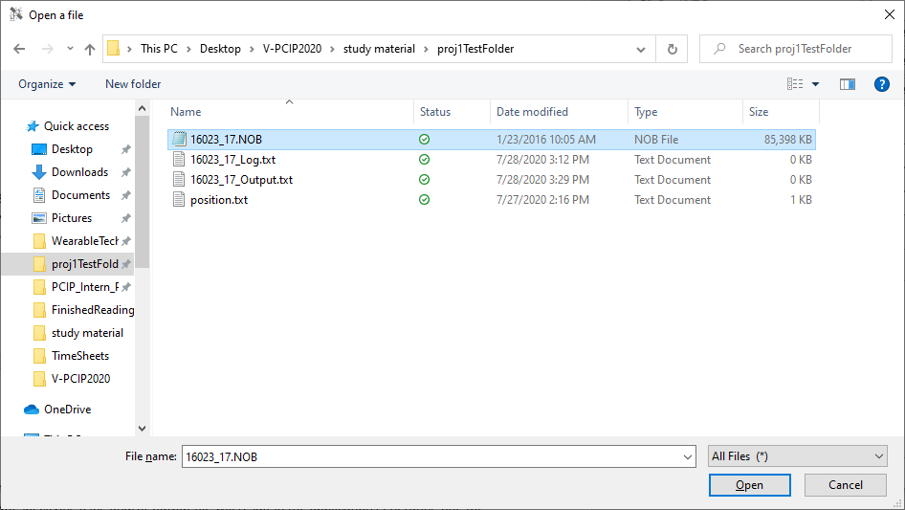

Figure : Selecting a Novatel data input file using the file browser

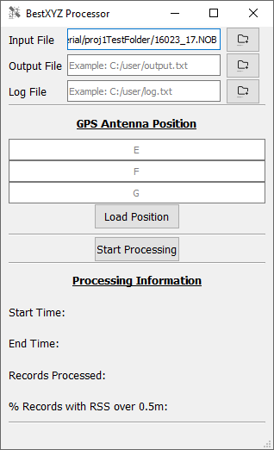

Figure : The selected input file path is shown

* 1. By using the browse button to the right of the “Input File” text entry field to browse your local device for the file. When a file has been selected using the file browser, the text entry field will be populated automatically.

1. Perform the same steps for the output and log file locations.
   1. Not specifying a log and/or output file will result in the application generating one when the “Process” button is clicked. The generated files will be based on the input file path.
2. Specify the GPS Antenna coordinates in meters using the ECEF E, F, and G entry fields or by loading them from a file.
   1. The text entry fields accept floating point values such as “12.54235436”
   2. When loading the values from a file they must be comma separated and on the same line. For example: “12.23, 5.55, 1.0”

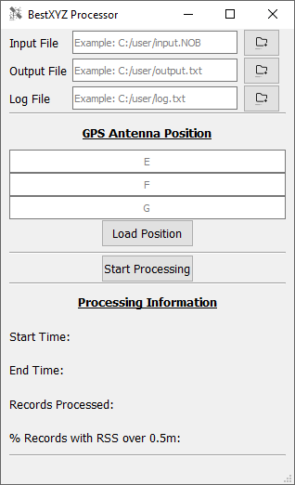

Figure : GPS Antenna Position text entry fields and file browser button

1. Begin Processing the Novatel data file by clicking on the “Process” button shown in figure 6
   1. GUI elements will be disabled as processing is performed

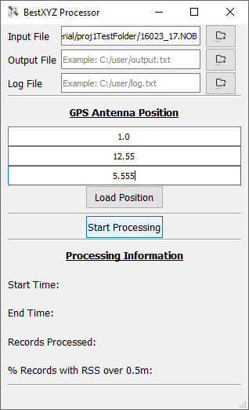

Figure : GUI ready to begin processing

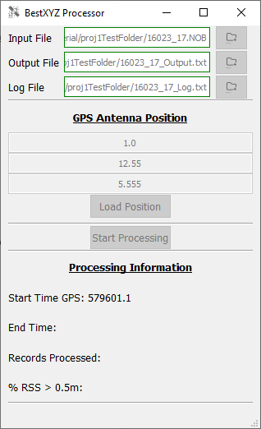

Figure : GUI during processing

1. When the GUI elements are re-enabled, the processing has completed, and output files populated. The “Processing Information” section under the start processing button will display some post run information.

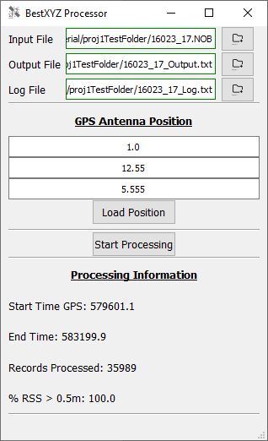

Figure : Post run GUI with Processing Information populated

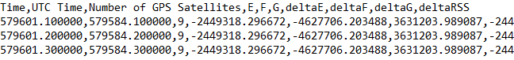

Figure : Truncated image of the output data file after processing

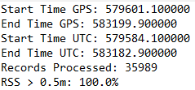

Figure : Output Log file after processing

1. Another round of processing can be started but the output and log file paths should be changed as to not overwrite the results from the previous run.

# KNOWN BUGS

## 3.1 Invalid Input file

When using a non-Novatel data file for the input file, the program will crash or behave unexpectedly.

# References

[1] Docs.novatel.com. 2020. *OEM7® Receiveruser Documentation*. [online] Available at: <https://docs.novatel.com/oem7/Content/Home.htm> [Accessed 30 July 2020].

[2] Noun Project. 2020. *Noun Project*. [online] Available at: <https://thenounproject.com/> [Accessed 30 July 2020].